Muhammad Naimat Ullah Khan

21K- 450

QUESTION NO 1:

MAIN:

TITLE My First Program (task.asm)

INCLUDE Irvine32.inc

.data

val1 DWORD 8000h

.code

main PROC

mov eax, val1

add eax, 1000h

call DumpRegs

exit

main ENDP

END main

OUTPUT:

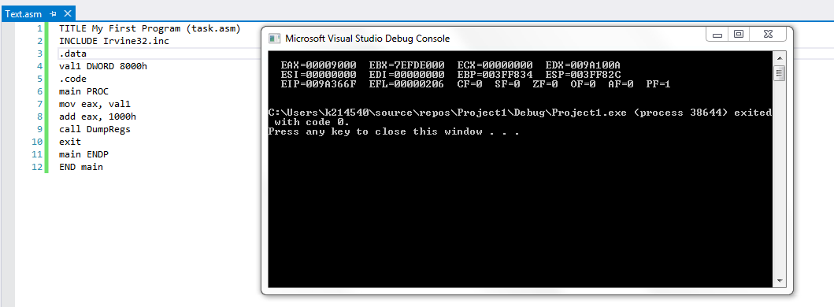

QUESTION NO 2:

Main:

TITLE My First Program (task.asm)

INCLUDE Irvine32.inc

.data

.code

main PROC

mov ax , 7FF0h

call DumpRegs

add al , 10h

call DumpRegs

add ah , 1

call DumpRegs

add ax , 2

call DumpRegs

exit

main ENDP

END main

OUTPUT:

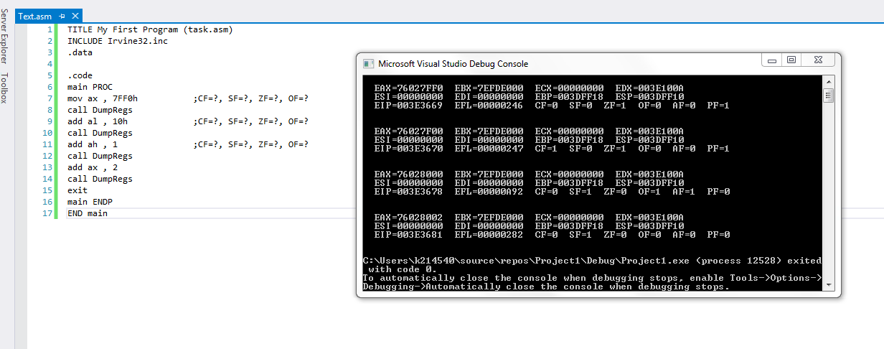

QUESTION NO 3:

Main:

TITLE My First Program (Text.asm)

INCLUDE irvine32.inc

.DATA

array DWORD 8,5,1,2,6

.CODE

main PROC

mov eax,[8+array]

xchg[0+array],eax

mov [8+array],eax

mov eax,[12+array]

xchg[4+array],eax

mov [12+array],eax

mov eax,[8+array]

xchg[12+array],eax

mov [8+array],eax

mov eax,[12+array]

xchg[16+array],eax

mov [12+array],eax

call DumpRegs

mov ESI, offset array

mov EBX, type array

mov ECX, lengthof array

call dumpmem

exit

main ENDP

END main

OUTPUT:

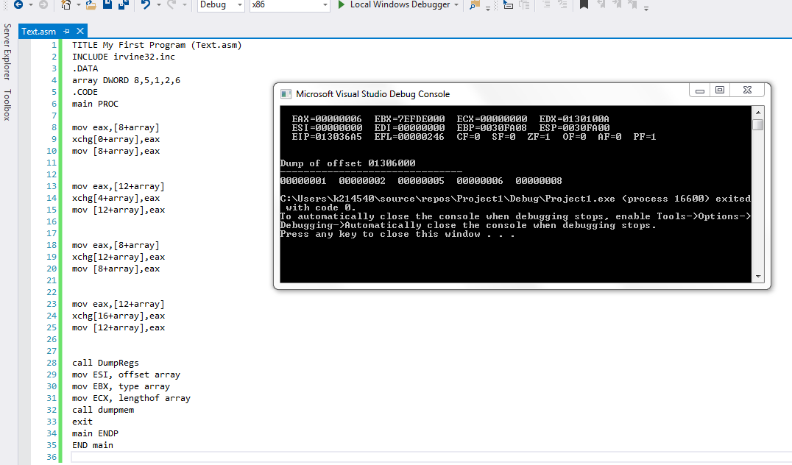

QUESTION NO 4:

Main:

TITLE My First Program (Text.asm.asm)

INCLUDE irvine32.inc

.data

arrayB BYTE 10, 20, 30

arrayW WORD 150, 250, 350

arrayD DWORD 600, 1200, 1800

SUM1 DWORD ?

SUM2 DWORD ?

SUM3 DWORD ?

.code

main PROC

movzx eax, arrayB

movzx ebx, arrayW

add eax, ebx

add eax, arrayD

mov SUM1, eax

call writeint

call crlf

movzx eax, [arrayB+1]

movzx ebx, [arrayW+2]

add eax,ebx

add eax, [arrayD+4]

mov SUM2, eax

call writeint

call crlf

movzx eax, [arrayB+2]

movzx ebx, [arrayW+4]

add eax,ebx

add eax, [arrayD+8]

mov SUM3, eax

call writeint

call crlf

call DumpRegs

exit

main ENDP

END main

Output:

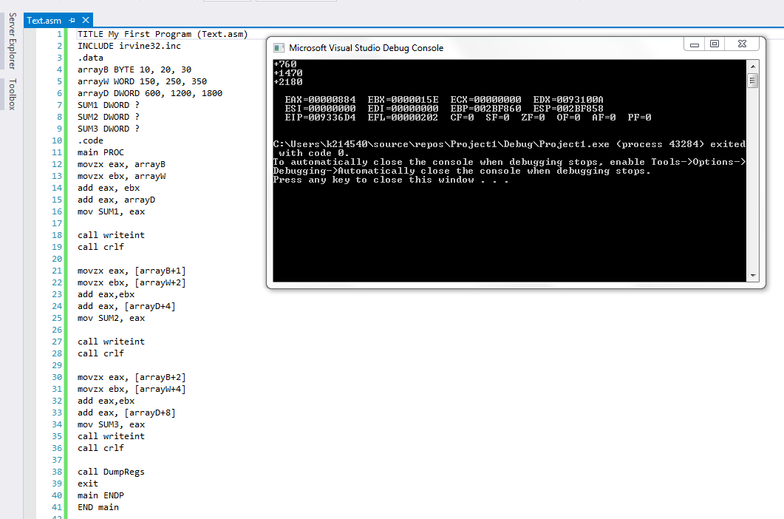

QUESTION NO 5:

Main:

TITLE My First Program (Text.asm)

INCLUDE irvine32.inc

.data

array1 BYTE 10h, 20h, 30h, 40h

array2 BYTE 4 DUP (?)

.code

main PROC

mov esi, OFFSET array1

mov edi, OFFSET array2

add esi,3

mov al, [esi]

mov[edi], al

dec esi

inc edi

call writeint

call crlf

mov al, [esi]

mov[edi], al

dec esi

inc edi

call writeint

call crlf

mov al, [esi]

mov[edi], al

dec esi

inc edi

call writeint

call crlf

mov esi, offset array2

mov EBX, type array2

mov ECX, lengthof array2

call Dumpmem

exit

main ENDP

END main

Output:

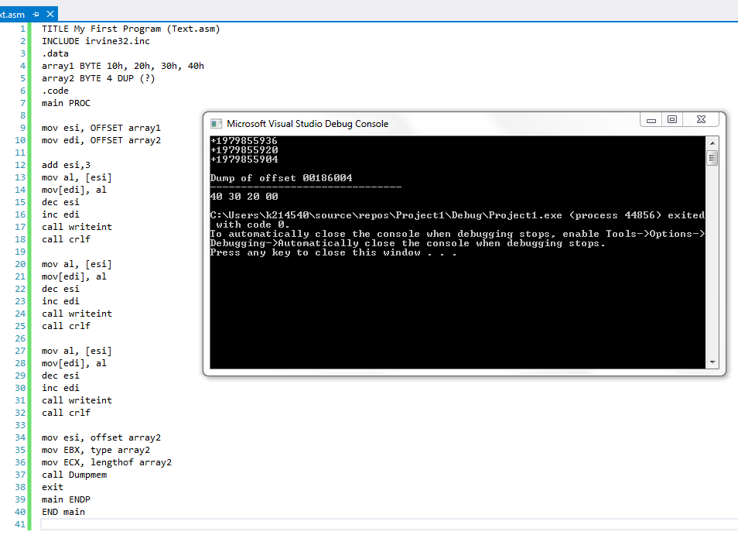

QUESTION NO 6:

Main:

TITLE My First Program (Text.asm)

INCLUDE irvine32.inc

.data

array1 DWORD 10, 20, 30, 40,50

.code

main PROC

mov eax,[array1]

sub eax, [array1+4]

sub eax, [array1+8]

sub eax, [array1+12]

sub eax, [array1+16]

call writeint

call crlf

call DumpRegs

exit

main ENDP

END main

Output:

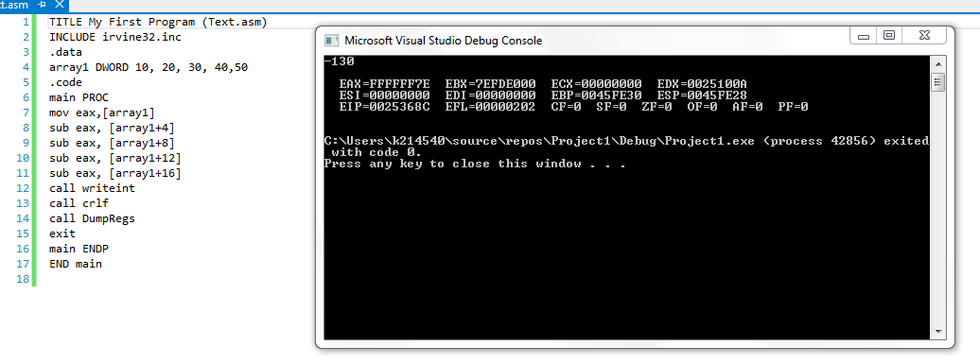

QUESTION NO 7:

Main:

TITLE My First Program

INCLUDE Irvine32.inc

.data

arrayB BYTE 60,70,80

arrayW WORD 150,250,350

arrayD DWORD 600,1200,1800

SUM1 DWORD ?

SUM2 DWORD ?

SUM3 DWORD ?

.code

MAIN PROC

mov eax,0

mov ebx,0

mov esi,0

movsx eax,arrayB[esi\*TYPE arrayB]

add esi,2

movsx ebx,arrayB[esi\*TYPE arrayB]

add eax,ebx

mov SUM1,eax

mov eax,0

mov ebx,0

mov esi,0

movsx eax,arrayW[esi\*TYPE arrayW]

add esi,2

movsx ebx,arrayW[esi\*TYPE arrayW]

add eax,ebx

mov SUM2,eax

mov eax,0

mov ebx,0

mov esi,0

mov eax,arrayD[esi\*TYPE arrayD]

add esi,2

mov ebx,arrayD[esi\*TYPE arrayD]

add eax,ebx

mov SUM3,eax

mov eax,SUM1

call WriteInt

call crlf

mov eax,SUM2

call WriteInt

call crlf

mov eax,SUM3

call WriteInt

call crlf

exit

MAIN ENDP

END MAIN

Output:

